
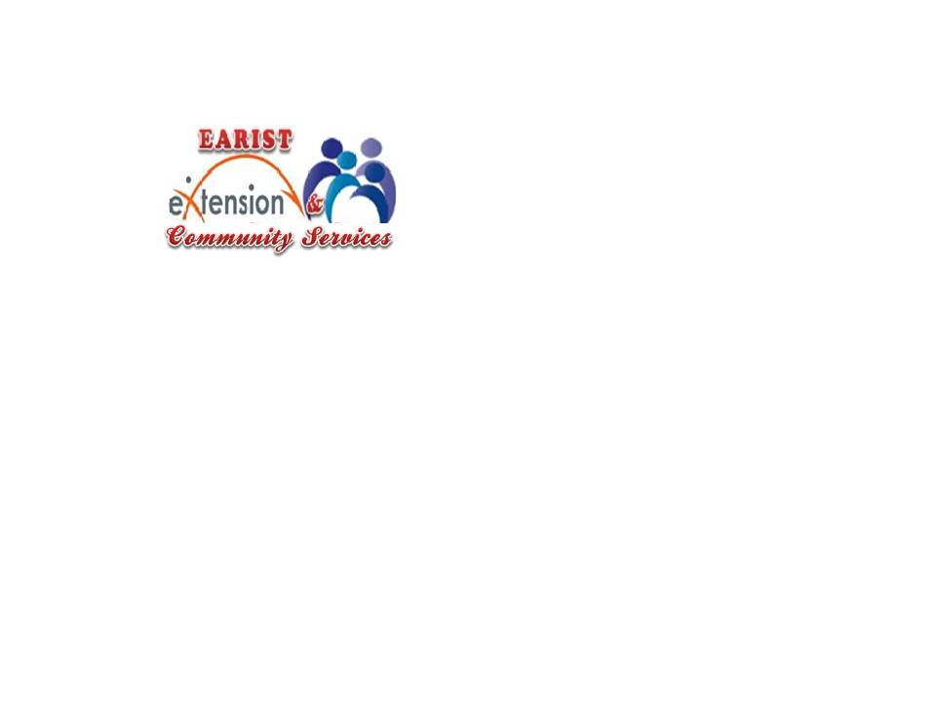

Republic of the Philippines
EULOGIO “AMANG” RODRIGUEZ
INSTITUTE OF SCIENCE AND TECHNOLOGY
Nagtahan, Sampaloc, Manila

OFFICE OF THE EXTENSION AND COMMUNITY SERVICES

MINUTES OF THE MEETING

BSCS/BSIT EXTENSION PROGRAM
February 25, 2026

Title of Activity: Extension Services Planning Meeting
Date of Meeting: February 24, 2026
Time: 9:00 am
Venue: Extension Office
Presiding Officer: Mr. Rowee M. Marfil
Recorder: Mr. Melvin G. Eballe

Agenda Proper

1. Confirmation of Activity Schedule
- The extension activity will proceed on March 5.
- Reimbursement of the approved budget will be observed following institutional guidelines.

2. Program Implementation & Task Assignments
A. Program and Materials
- Program & Tarp Template Design – c/o OJT Extension Services
- Certificates (Participants and Faculty) – c/o OJT & Mr. Eballe
- Evaluation Forms & Summary Report – c/o OJT & Mr. Eballe
- Attendance Monitoring – Ms. Dumpit
- Master of Ceremony (MC) – Ms. Surio
B. Logistics and Budget
- Food and Internet Budget – c/o Melvin
- Purchasing of Food (8:00 AM) – Mr. Soriano
- Bring mouse and keyboard – CSTG Officers and OJT
- Letter Request for Use of Computer Laboratory – ℅ Mr. Eballe
- Technical Support – CSTG Organization & Mr. Marfil
C. Program assignment

Digital Skills for the Modern Workplace: Google Docs and Sheet Forms
Extension Program
11:00 - 1:00
Doxology CSTG Officers
National Anthem Audio Visual Presentation
Opening Remarks Dr. Liwanag
Special message Dr. Mabansag
Dr. Mamaradlo
Program proper Mr. Soriano, Mr. Eballe, and Mrs. Domingo
Session 1: Google Docs for Barangay Documentation - March 5, 2026
Session 2: Google Sheets for Data Management - March 12, 2026
Session 3: Google Forms for Public Engagement - March 19, 2026
Workshop
Certificates Mrs. Dumpit
Closing Remarks Mr. Marfil

3. Session Flow and Speaker Assignments
Session | Topic | Speaker | Assigned Responsibilities
Session 1 | Google Docs | Mr. Soriano | Prepare presentation materials, hands-on activity, and Progress Report 1
Session 2 | Google Sheets | Mrs. Domingo | Prepare presentation materials, workshop exercises, and Progress Report 2
Session 3 | Google Forms | Mr. Eballe | Prepare presentation materials, practical activity, and Terminal Report

4. Reports Required
- Progress Report 1 - 1 day after the session 1 ℅ Mr. Soriano
- Progress Report 2 - 1 day after the session 2 ℅ Mrs. Domingo
- Terminal Report - 1 day after the session 3 ℅ Mr. Eballe
- Liquidation/Reimbursement -1 days after each session ℅
  - Session 1 ℅ Mr. Eballe
  - Session 2 ℅ Mr. Marfil
  - Session 3 ℅ Mrs. Dumpit

5. Other Agreements
- All assigned personnel must coordinate with the Extension Services Office before March 5.
- All documentation (photos, attendance sheets, and evaluation results) must be submitted immediately after the activity for consolidation.

Confirmation and Approval of the Minutes

The minutes of the meeting were presented to the body for review and verification. After careful consideration, the participants confirmed that the minutes accurately reflect the discussions, agreements, and assigned responsibilities during the meeting.

Upon motion duly made and seconded, the Minutes of the Meeting were approved and confirmed by the participants.

Name | Signature | Date

Prepare by:

MELVIN G. EBALLE, MIT
Project Leader

Noted by:

ROWEE M. MARFIL, MBA, MIT
Head, Extension Services

