December 9, 2025

DR. ROGELIO T. MAMARADLO
President
EARIST, Manila

Sir:

Good day!

In line with the conducted Extension Program titled “Digital Skills for the Modern Workplace: Mastering Google Workspace” held on December 7, 2025, 1st Session, at Blk 4 Sampaloc Ave. Barangay Poblacion 2, GMA Cavite, the undersigned respectfully submits herewith the reimbursement request for the financial assistance/fund released for the said activities.

The report includes a detailed breakdown of expenses incurred during the 1st session, supported by the corresponding receipts and necessary documentation for transparency and accountability.

Attached herewith are the official receipts and other supporting documents for your reference and verification.

Thank you very much for your continued support in the implementation of our extension services.

Respectfully yours,

MR. ROWEE M. MARFIL
Assistant Professor 1

Recommending Approval:

DR. AGNES N. COO
Campus Administrator

DR. ERIBERTO R. ASTORGA JR.
Director for Extension Services

DR. ERIC C. MENDOZA
Vice President for Academic Affairs

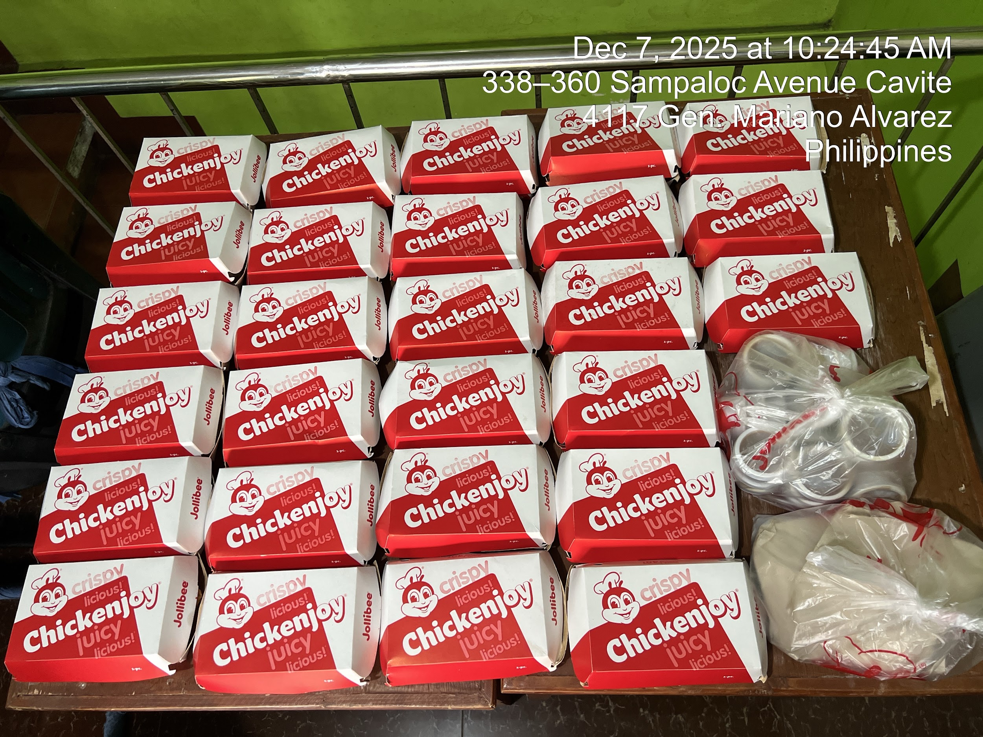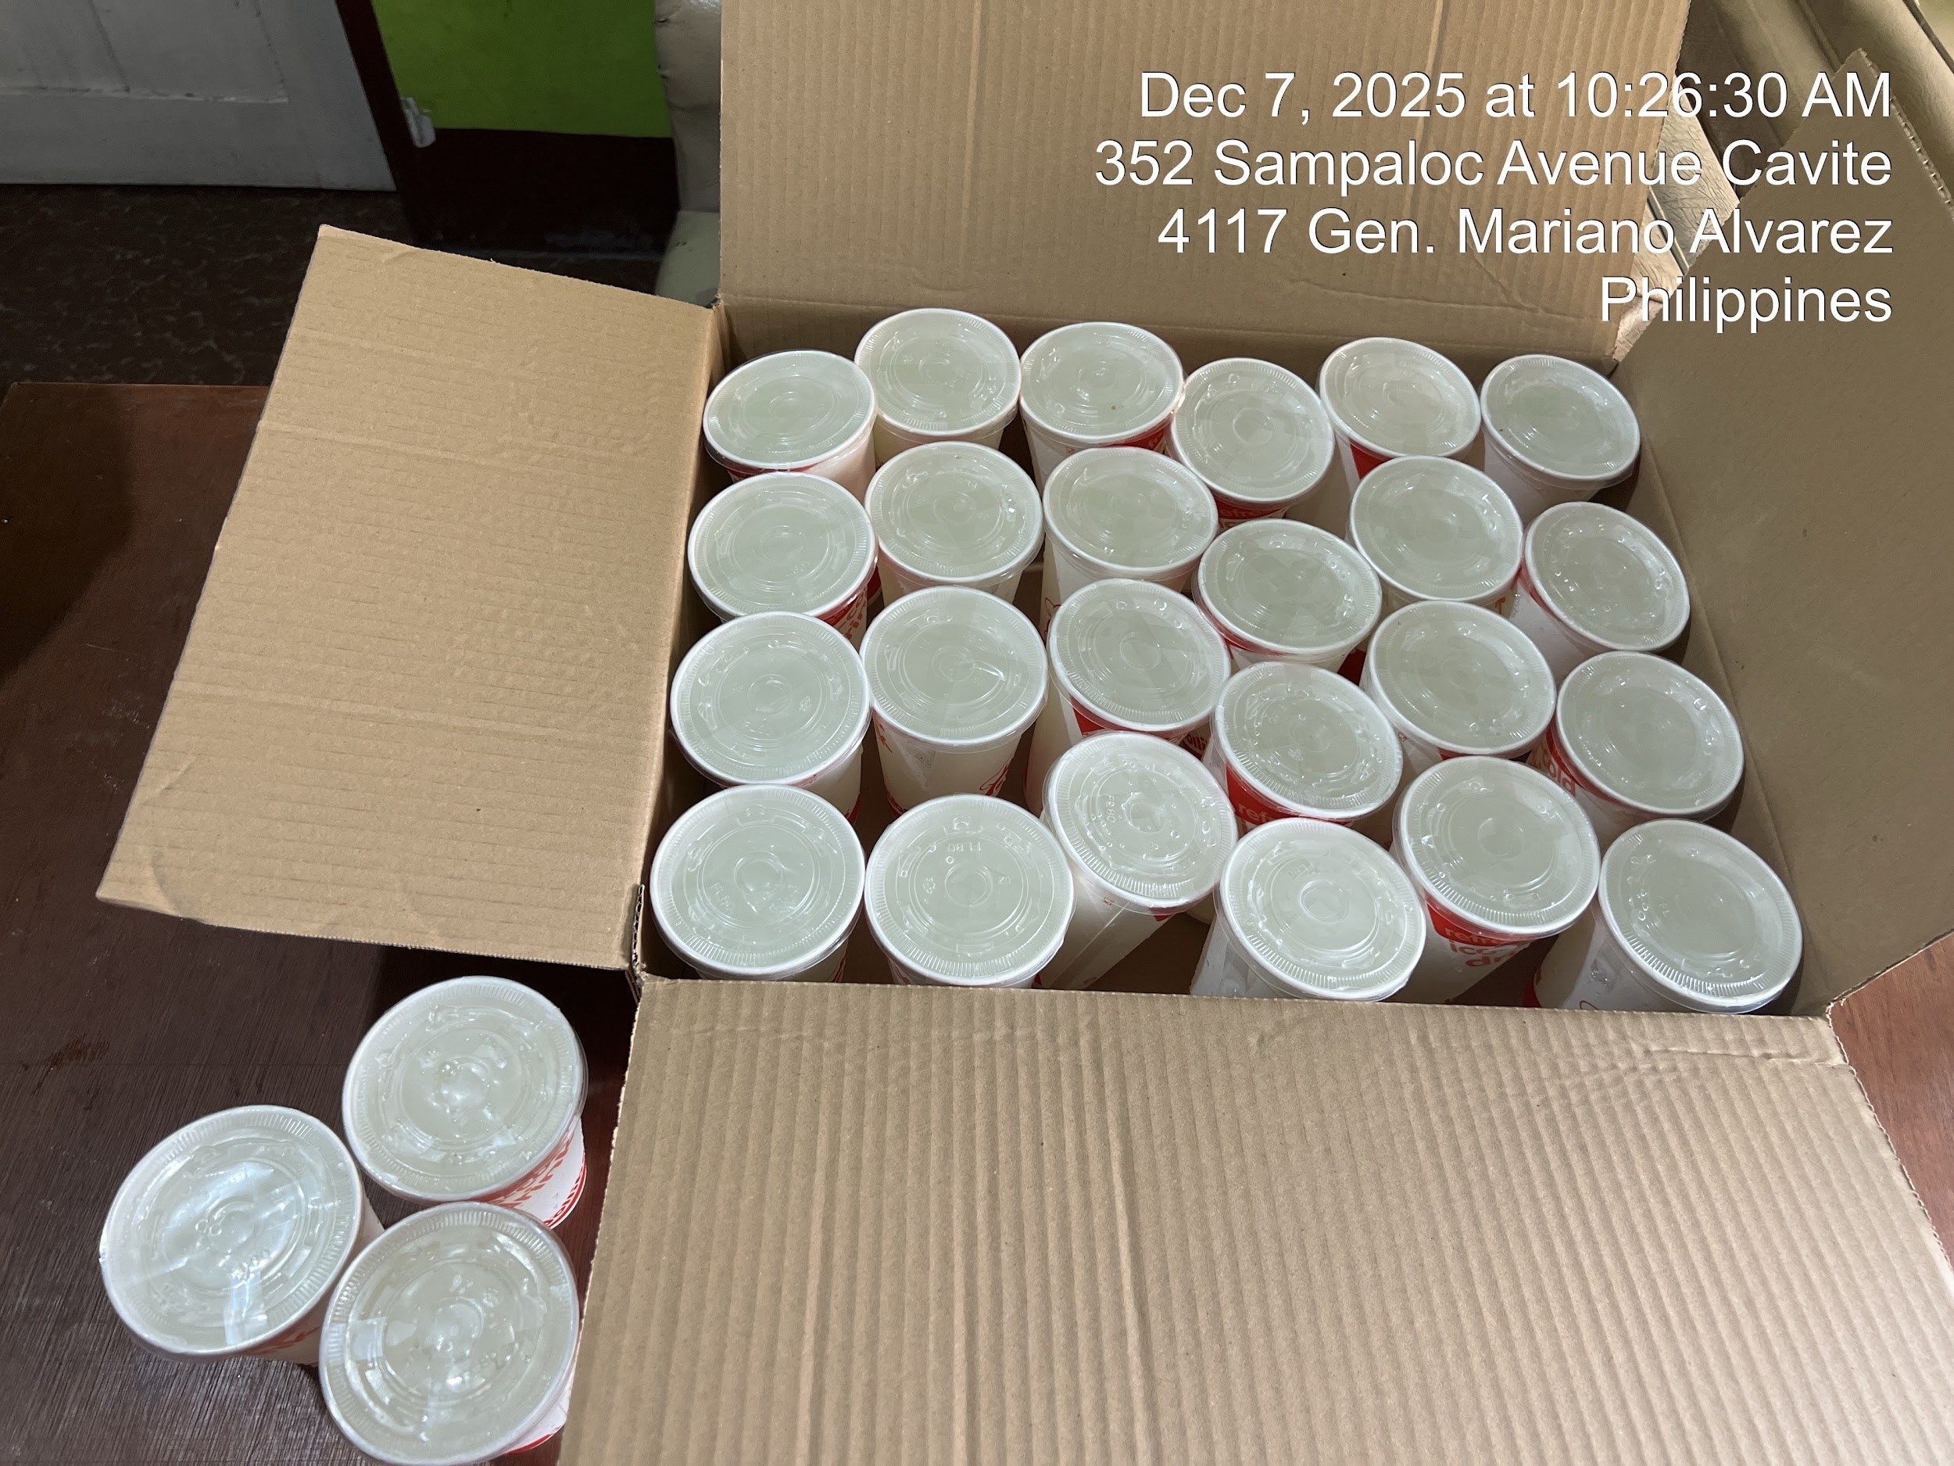
Special Paper
Black Ink
Colored Ink
Meals
Velum paper

Special Order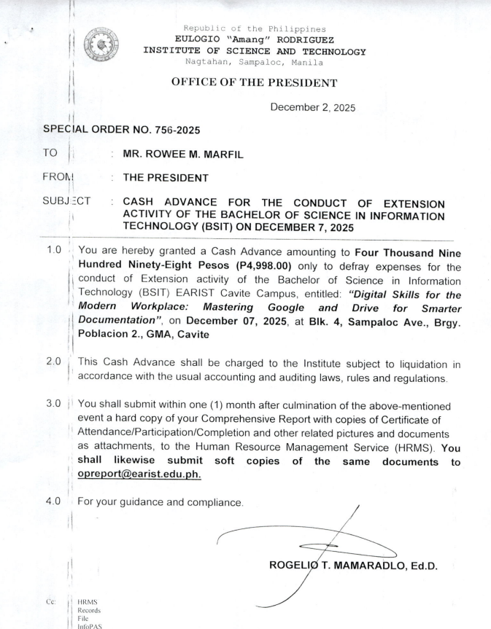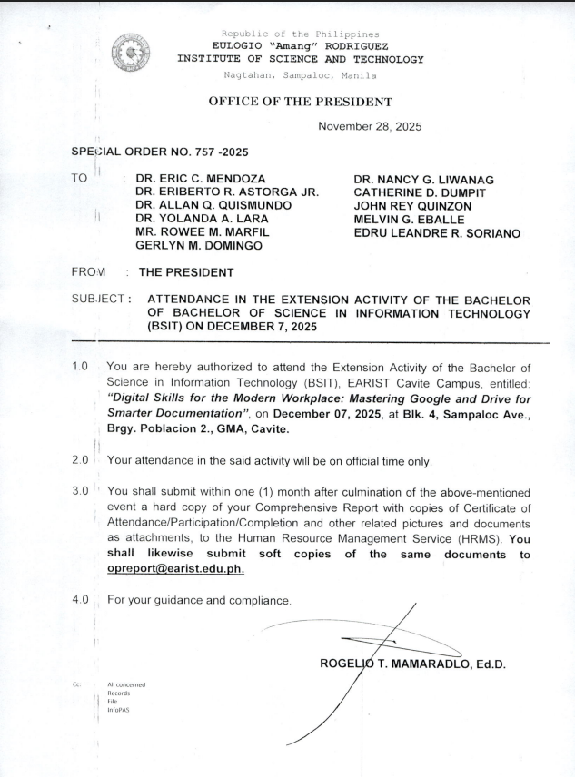

EXTENSION ACTIVITY

Liquidation Report

“Digital Skills for the Modern Workplace: Mastering Google Workspace”

Summary of Expenses: December 7, 2025, First Session.

Item | Qty | Amt | Total
Meal | 27 | ₱ 115.00 | ₱ 3,105.00
Total Amount |  |  |  | ₱ 3,105.00
Tarpualine | 1 | ₱ 240.00 | ₱ 240.00 | ₱ 240.00
Certificates
Bond paper long | 1 | ₱ 248.00 | ₱ 248.00
Special Paper | 4 | ₱ 43.00 | ₱ 172.00 | ₱ 420.00
ink black | 2 | ₱ 296.00 | ₱ 592.00 | ₱ 592.00
Ink colored | 2 | ₱ 308.00 | ₱ 616.00 | ₱ 616.00
Total Amount
 |  |  | Grand Total | ₱ 4,973.00

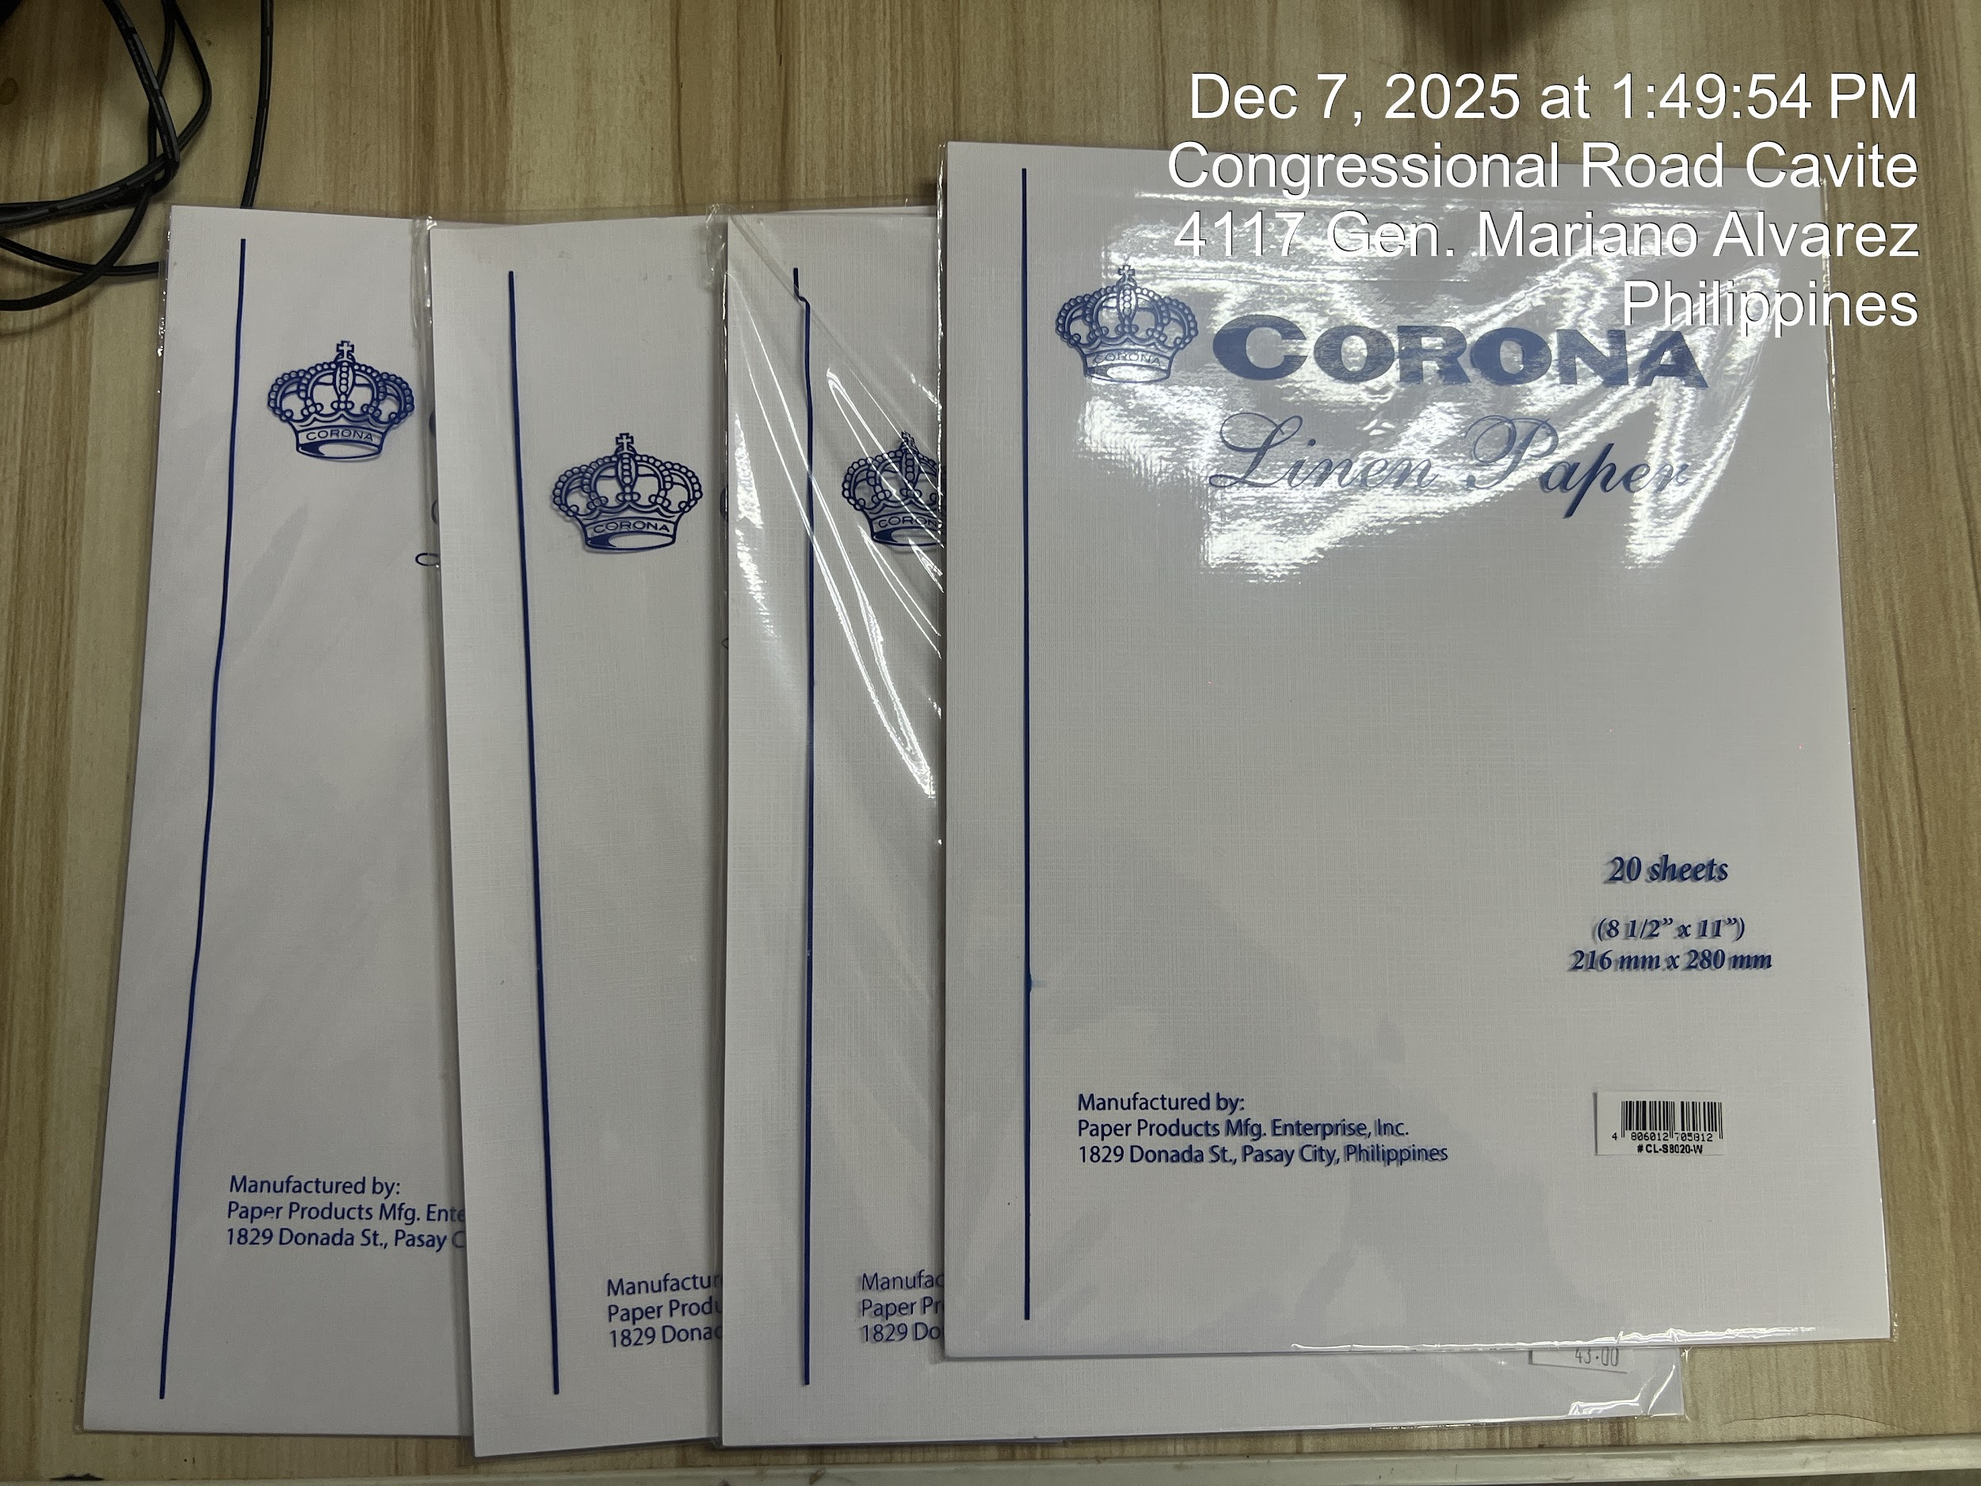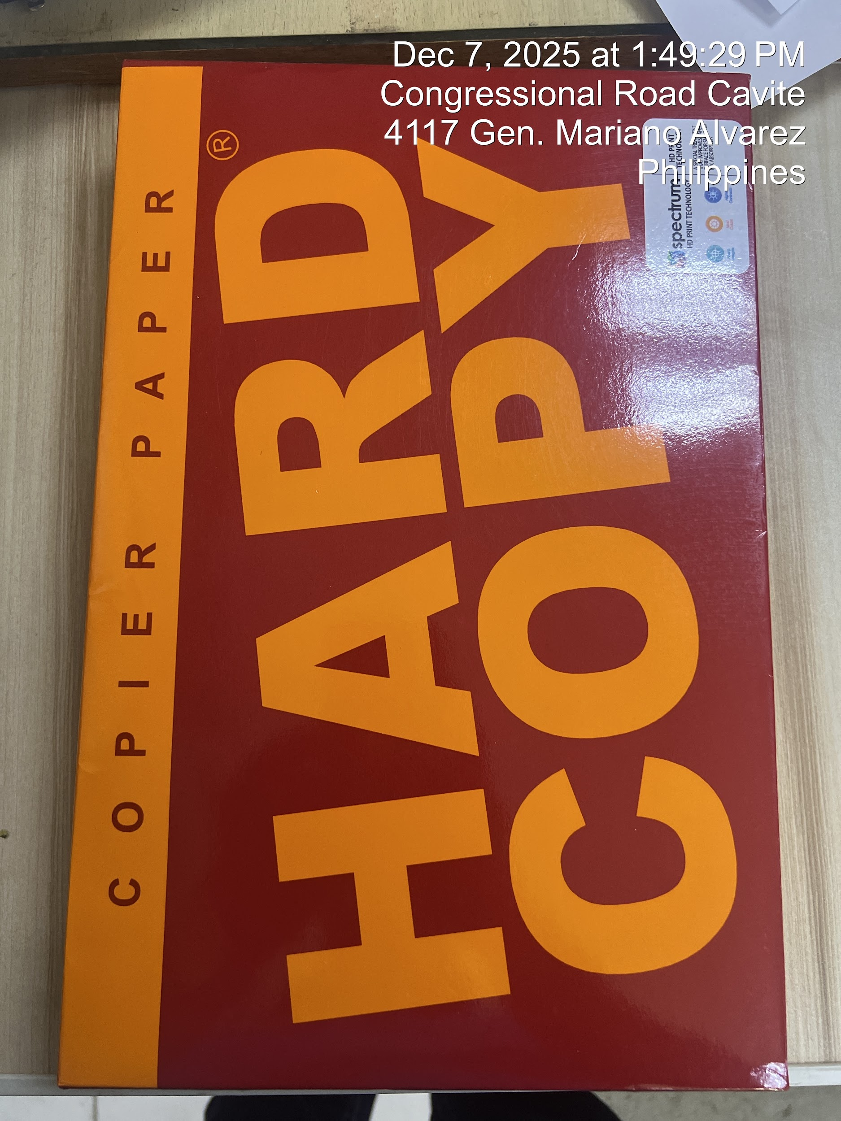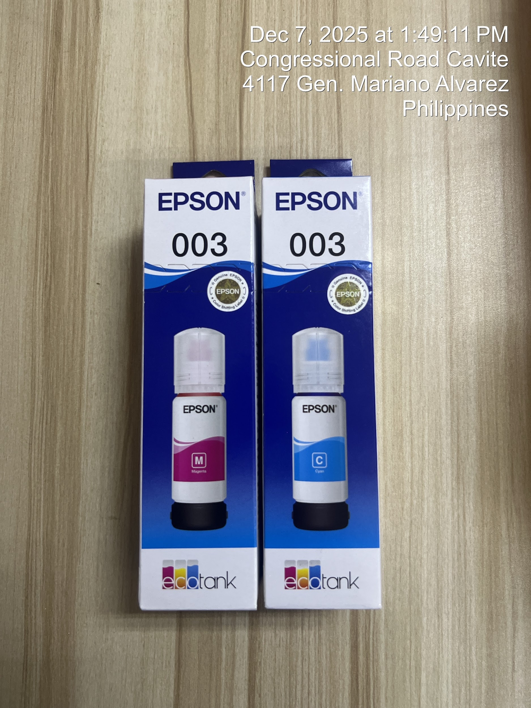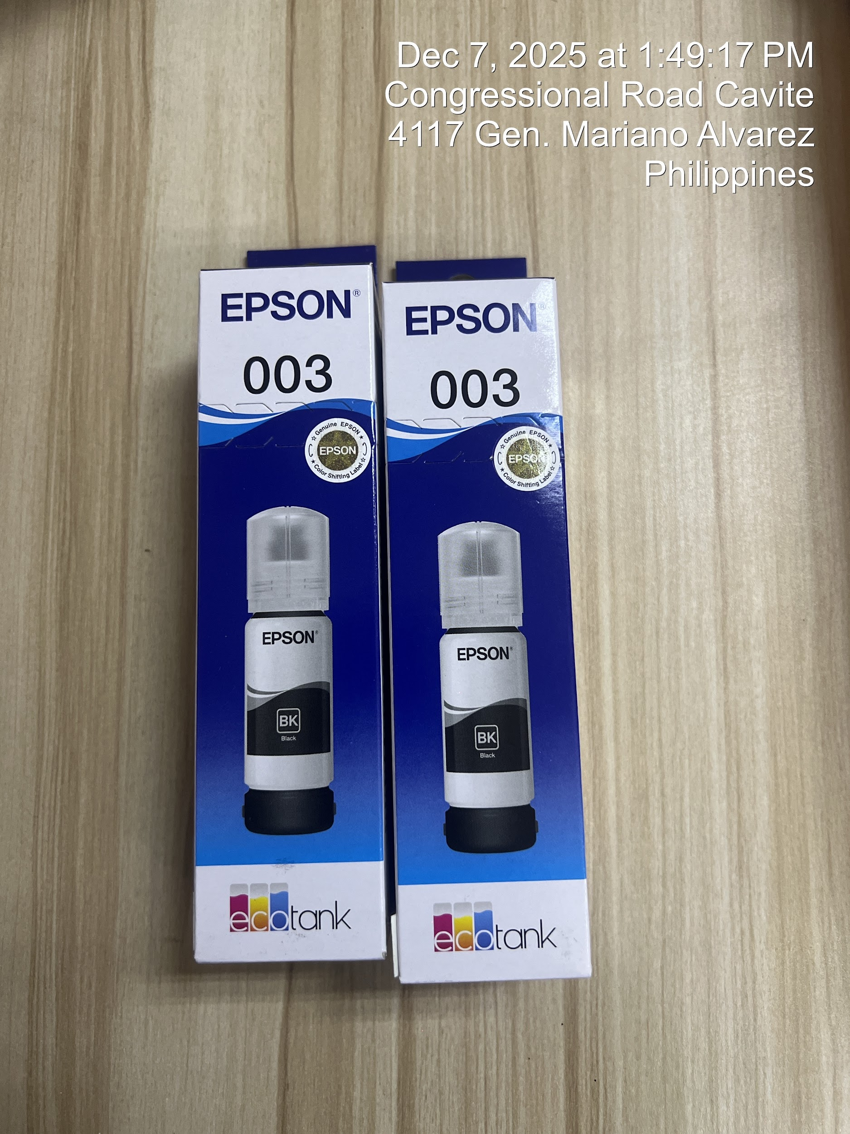
Ink
Bond paper
Special paper

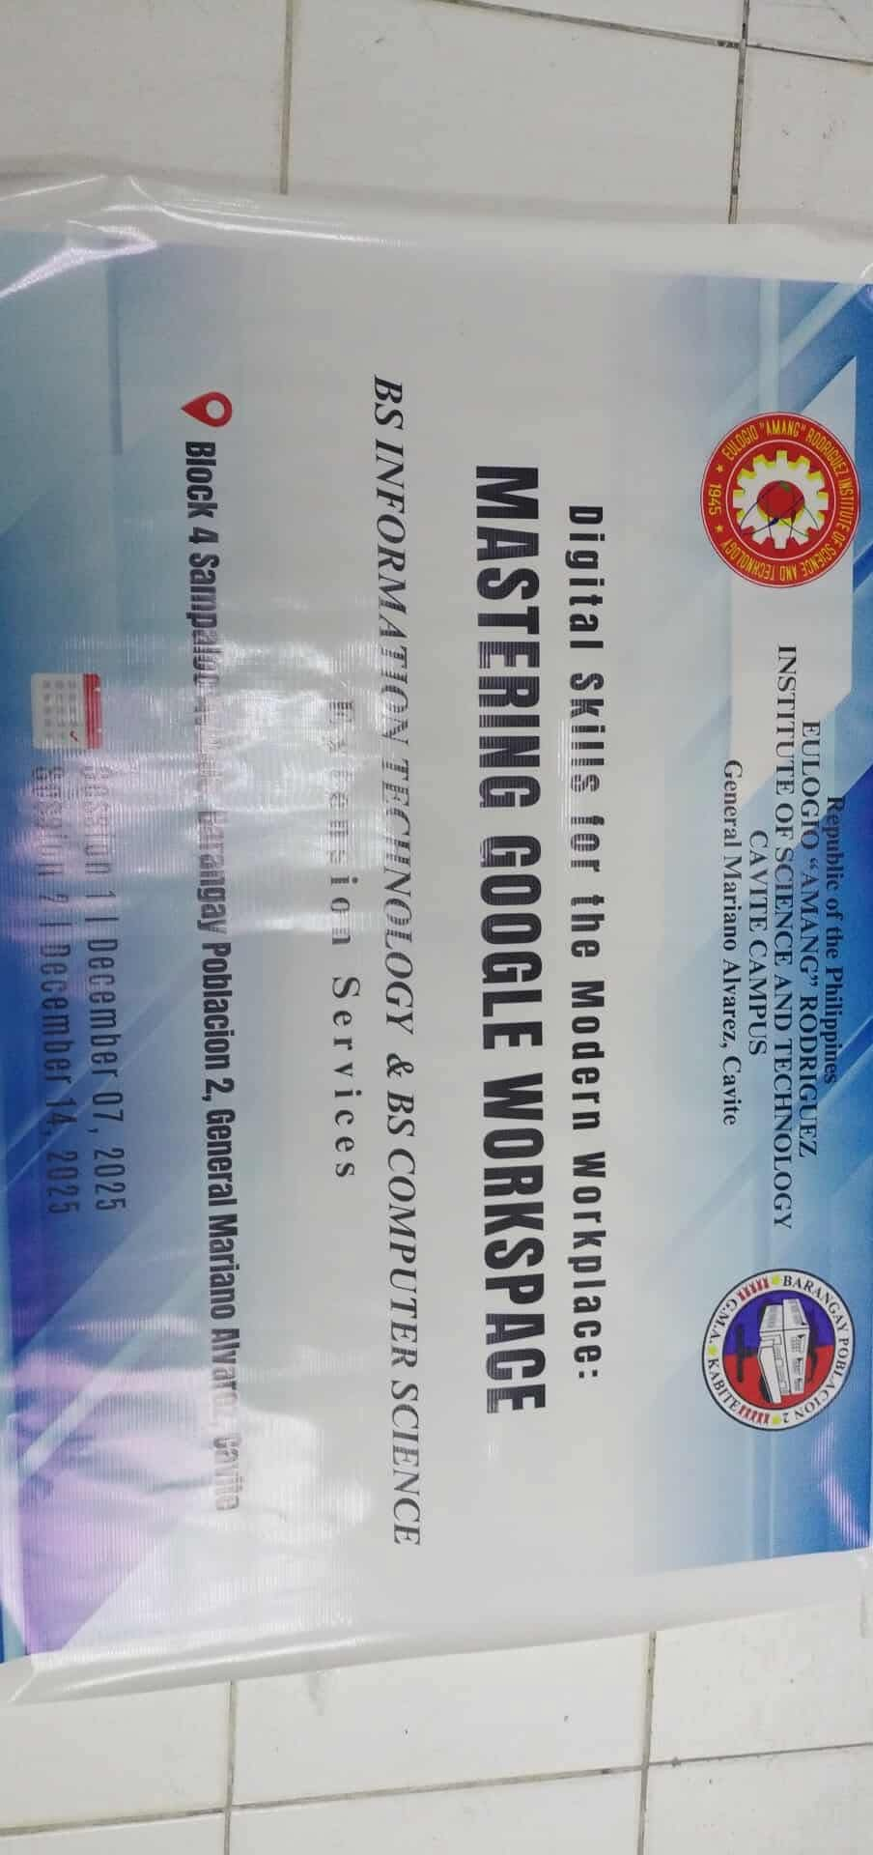

Tarp

EXTENSION ACTIVITY

Liquidation Report

“Digital Skills for the Modern Workplace: Mastering Google Workspace”

Summary of Expenses: December 14, 2025, Second Session.

 | Item | Qty | Amt | Total
Food | Burger | 11.00 | ₱ 72.00 | 792.00
Food | Spag | 30.00 | ₱ 77.00 | 2,310.00
Food | Total Amount |  |  |  | ₱ 3,102.00
Certificates | Bond paper long | 1.00 | ₱ 248.00 | 248.00
Certificates | Special Linen Paper | 4.00 | ₱ 43.00 | 172.00 | ₱ 420.00
Certificates | ink black | 2.00 | ₱ 296.00 | 592.00 | ₱ 592.00
Certificates | Ink colored | 2.00 | ₱ 308.00 | 616.00 | ₱ 616.00
Grand Total |  |  |  |  | ₱ 4,730.00
