
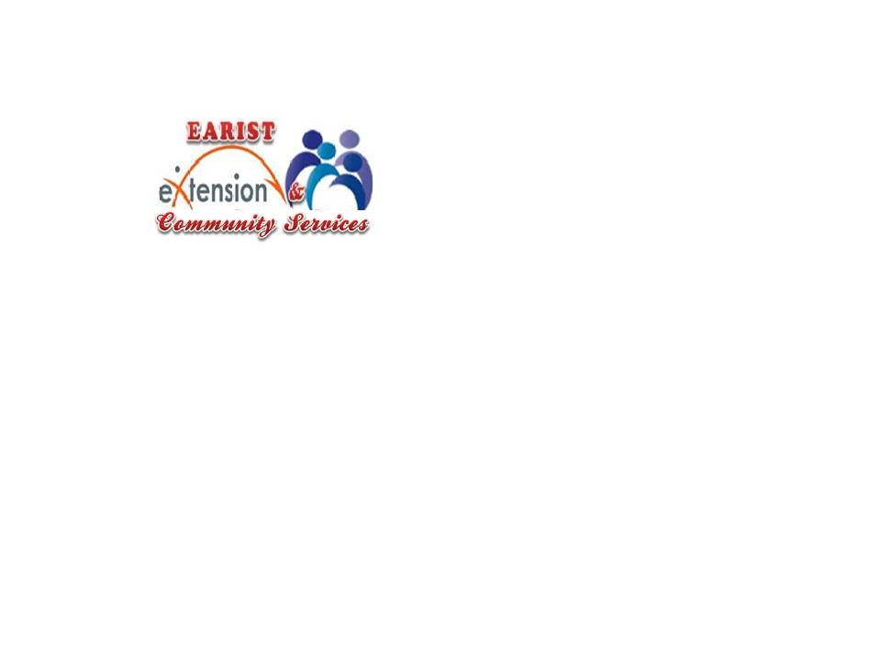

Republic of the Philippines
EULOGIO “AMANG” RODRIGUEZ
INSTITUTE OF SCIENCE AND TECHNOLOGY
Nagtahan, Sampaloc, Manila

OFFICE OF THE EXTENSION AND COMMUNITY SERVICES

PROJECT TERMINAL REPORT

Date: September 15, 2025

- Extension Project Title: Technology Innovation for Community Transformation:
“Integration of Education Mobile learning Tools’
Head of Extension: Dr. Agnes N. Coo
Dr. Eriberto R. Astorga, Jr.
Dr. Eric C. Mendoza

Proponents : Bachelor of Science in Computer Science
Bachelor of Science in Information Technology

Project Leader : Catherine D. Dumpit
Member(s) :
Gerlyn M. Domingo Rowee M. Marfil Melvin G. Eballe
Dr. Nancy G. Liwanag Florence B. Ferrer Michael Borja

- Executive Summary:

Rationale and Objectives
Educational mobile applications such as Babel, EduQ and QuizTriv will serve the students to motivate them to learn in an enjoyable way. By integrating quizzes, games, and simulations, these apps transform lessons into interactive experiences. This approach not only makes learning more engaging and fun but also encourages active participation, improves retention, and supports different learning styles.
- Babel - easier translation of different languages
- EduQ - enhance vocabularies and sentence structure
- QuizTriv - enhance learning in science, art and history

Project Beneficiaries
Monte Cristo Research and Educational Institute, GMA Cavite

Personnel Involved
EARIST Cavite Faculty, CSTG Officers, Monte Cristo Research and Educational Institute Faculty and Students

Strategies for Implementation
The faculty of EARIST Cavite Campus, in collaboration with Monte Cristo Research and Educational Institute, conducted two learning sessions to introduce Babel, EduQ, and QuizTriv as supplementary teaching and learning materials. During the sessions, the speakers discussed the features, functions, and educational benefits of the applications, and guided both students and faculty in exploring how these tools can be effectively integrated into classroom activities to enhance engagement and learning outcomes.

Project Duration
August 15, 2025 & August 29, 2025

- Project Budgetary Requirement (including Counterpart contributions, Source of Funds)

Funded

- Conclusions
The sessions successfully demonstrated the potential of Babel, EduQ, and QuizTriv as valuable supplementary tools for teaching and learning. By equipping both students and faculty with the knowledge and skills to use these applications, the activity fostered greater engagement, encouraged interactive learning, and laid the groundwork for more innovative and technology-driven classroom practices.

- Recommendations
Conduct follow-up seminars and regular evaluations to strengthen the integration of Babel, EduQ, and QuizTriv in classroom activities, ensuring their sustainability and effectiveness in enhancing teaching and learning.

- Documentation
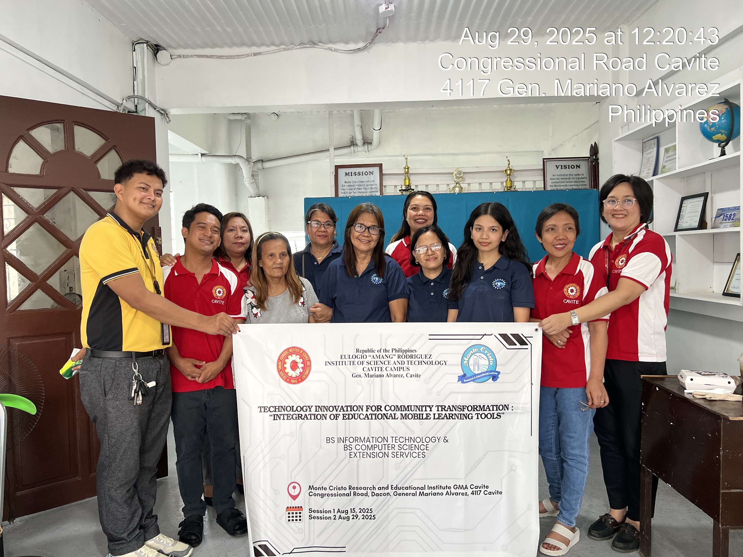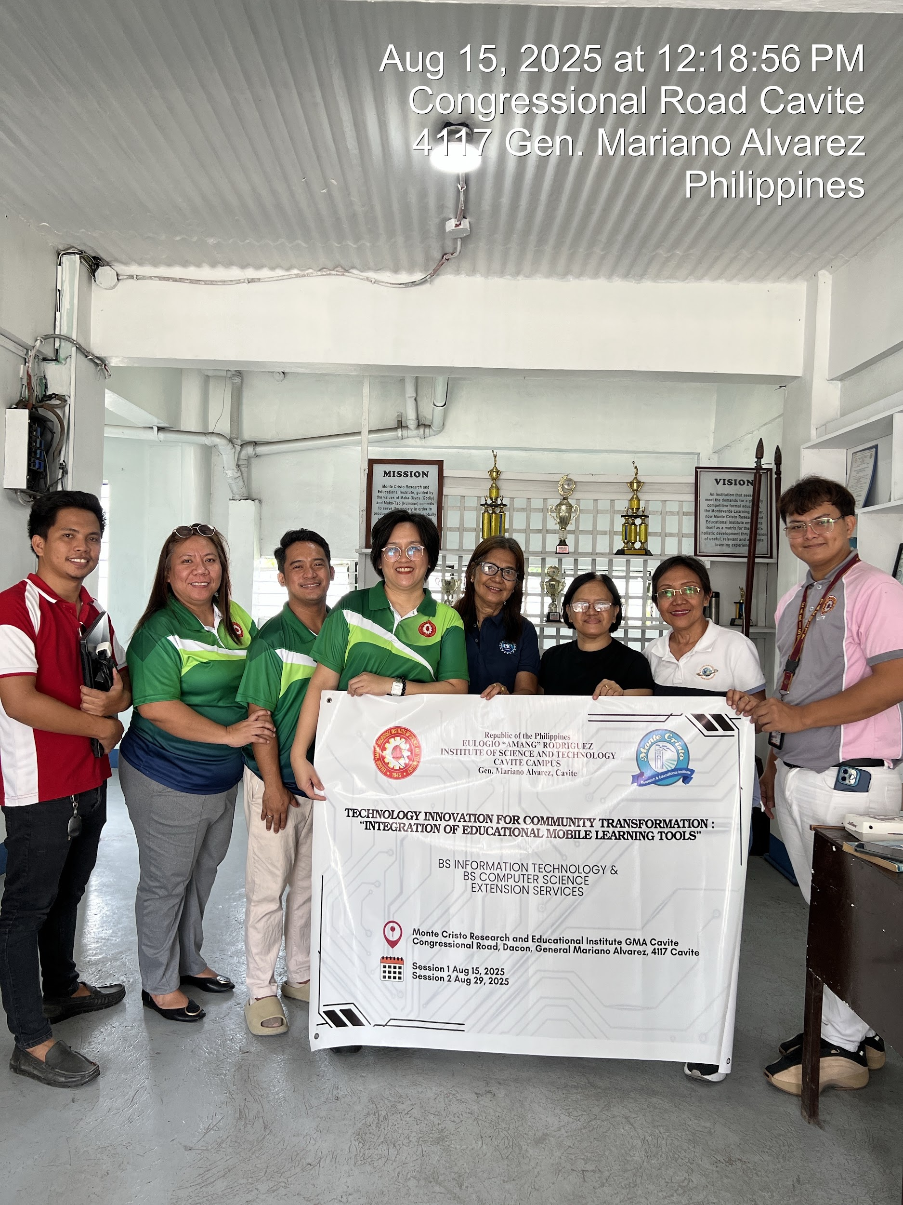
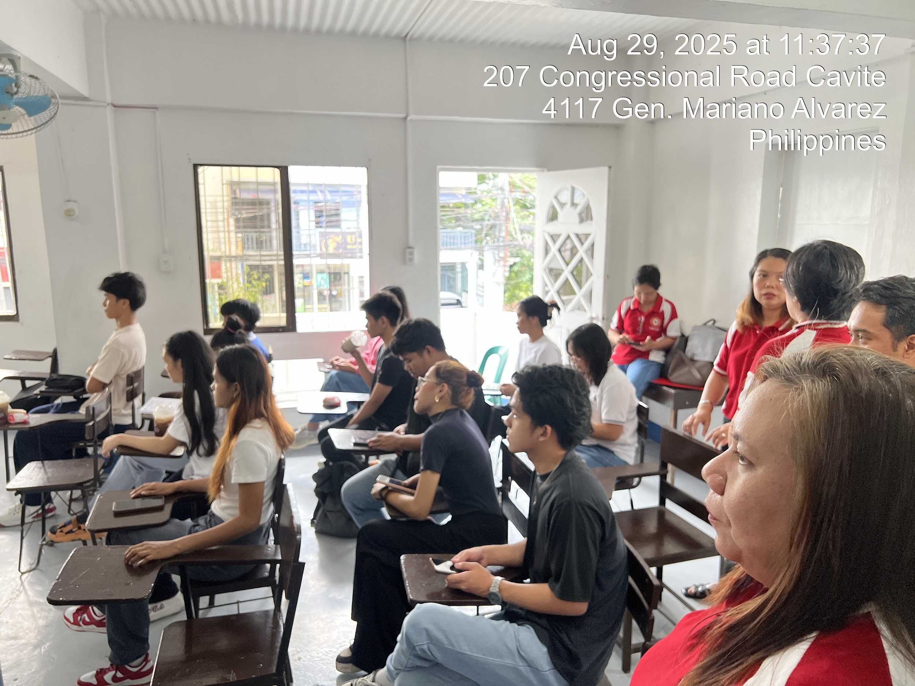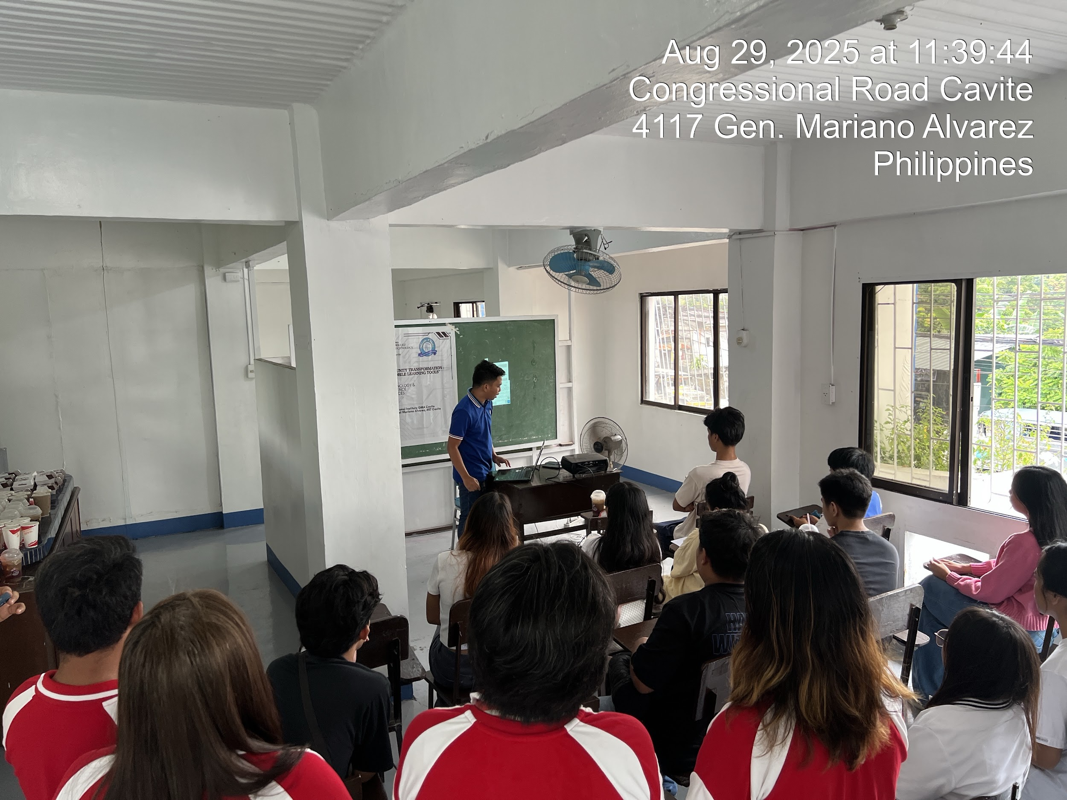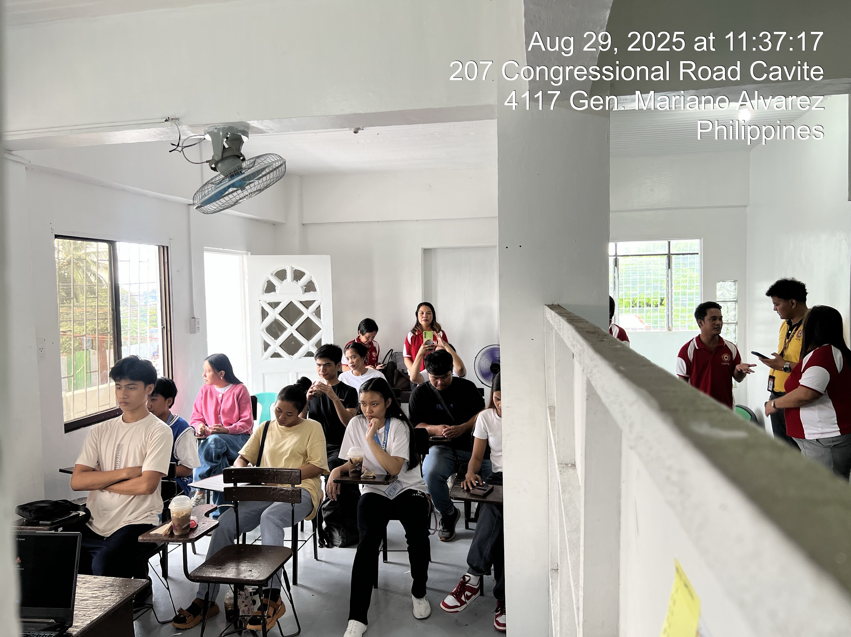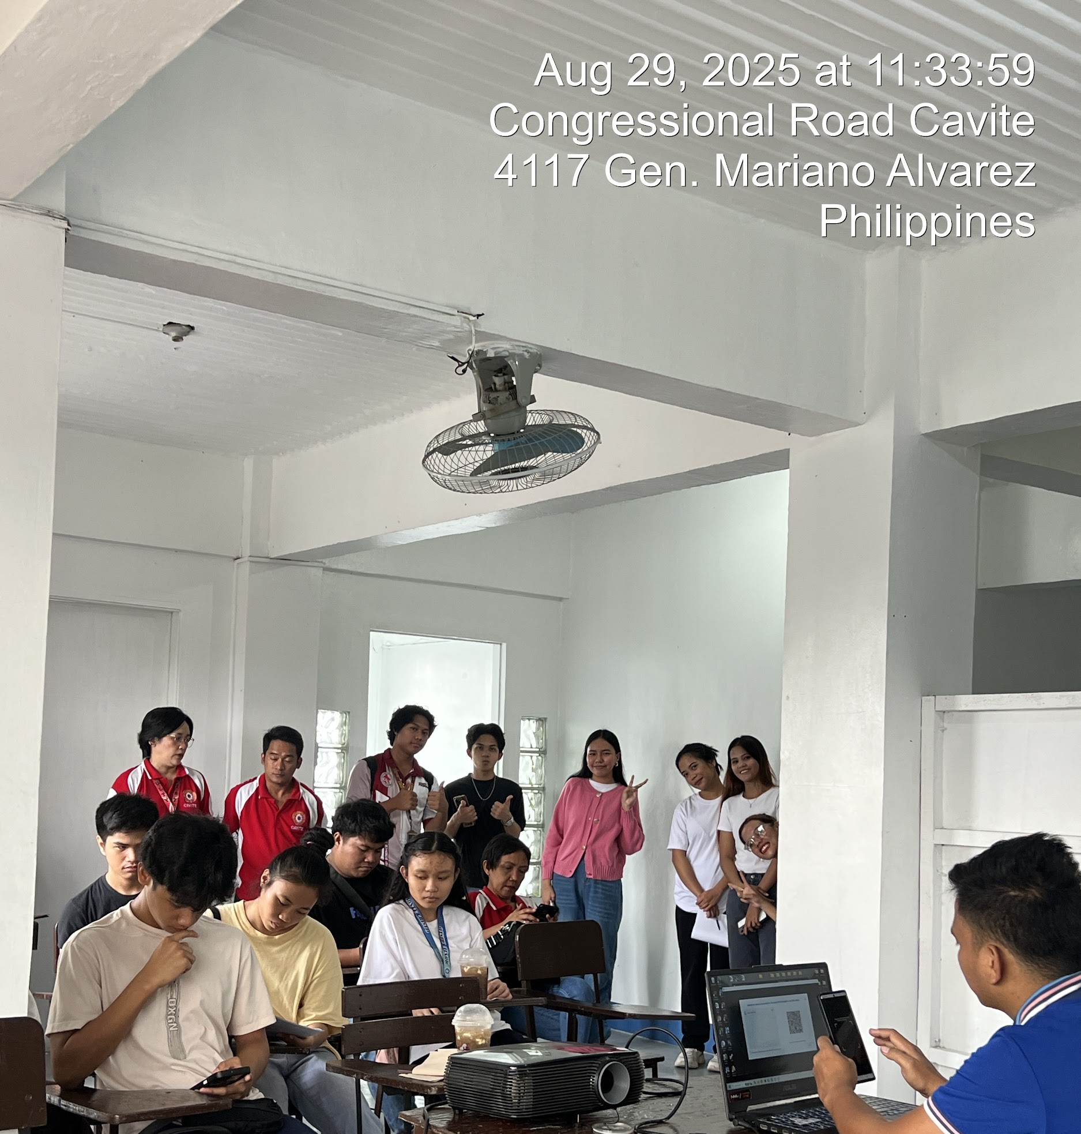

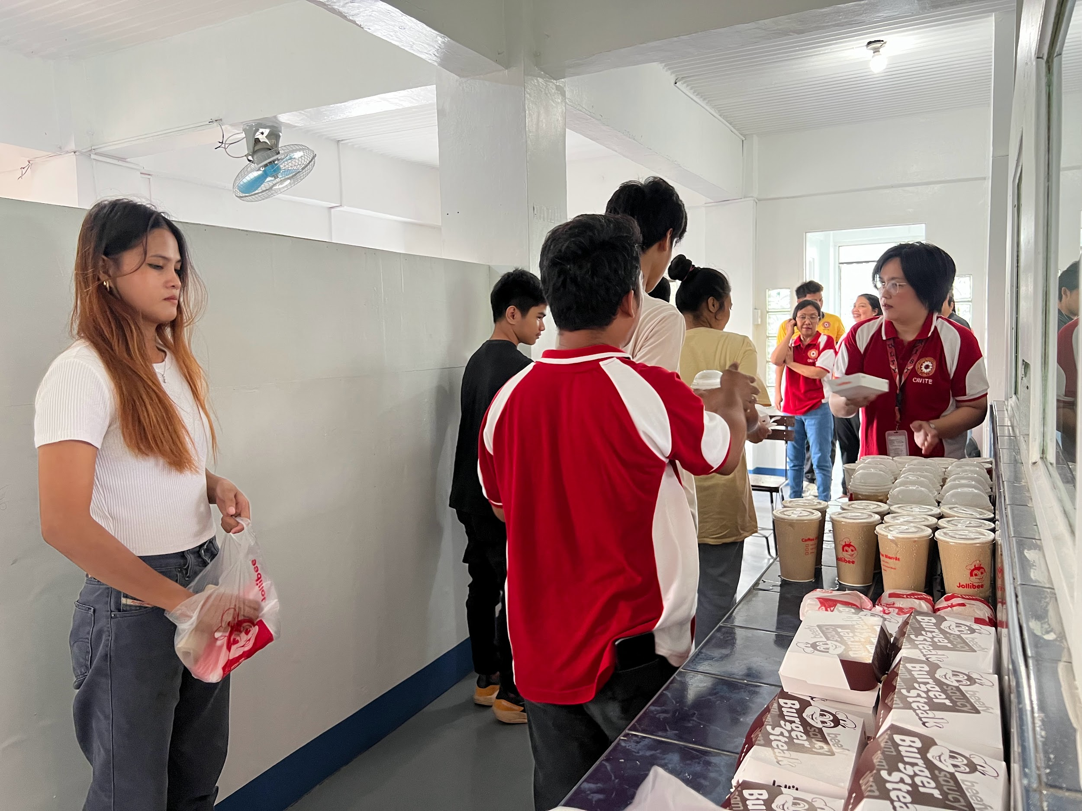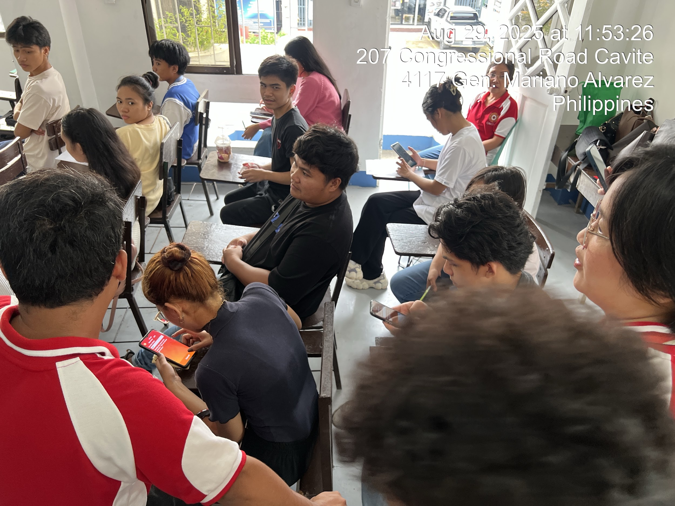

Submitted by: Noted:

DR. AGNES N. COO
Program Extension Project Chair Campus Administrator

Submitted by:

MRS. CATHERINE D. DUMPIT
Project Leader

Noted by:

MR. ROWEE M. MARFIL DR. JACEL D. MABANSAG
Head, Extension Services Campus Administrator

Recommending Approval:

DR. ERIBERTO R. ASTORGA JR.
Director

